**CE101 Engineering Drawing July- Nov 2019**

**Indian Institute of Technology Guwahati**

**Lab Sheet-10 Isometric Projections Tuesday Morning**

**Max Marks: 80 Date: 29.10.2019**

**Q. 1 Draw the three possible ways of representing the isometric projection of a pentagonal prim side of base 40 mm and height 70 mm. [15 marks]**

**Q. 2 Following figure shows orthographic views of an object. Draw its ISOMETRIC VIEW. [15 marks]**

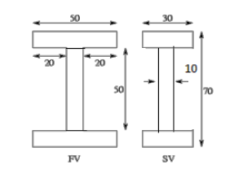

**Q.3 Draw the isometric view of frustum of a pentagonal pyramid resting on HP. The frustum is 70 mm high and the sides of its base and top face are 50 mm and 30 mm respectively. [25 marks]**

**Q.4 Following figure shows orthographic views of an object. Draw its ISOMETRIC VIEW. [25 marks]**

